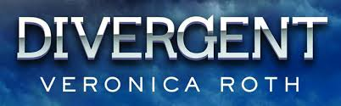
Answers

Chapter 31:

- Why does Tobias have so many tattoos?
- He thinks they have it wrong by dividing everyone into factions. He wants to be all the qualities: brave, selfless, honest, intelligent, and peaceful.

Chapter 32:

- What is Tris’ ranking after the fear landscape phase of training?
- 1st place.

- What does Tris realize about the Erudite plan?
- They will control the Dauntless with serum.

