The Strange & Curious Tale of the Last True Hermit

By Michael Finkel

For nearly thirty years, a phantom haunted the woods of Central Maine. Unseen and unknown, he lived in secret, creeping into homes in the dead of night and surviving on what he could steal. To the spooked locals, he became a legend—or maybe a myth. They wondered how he could possibly be real. Until one day last year, the hermit came out of the forest

The hermit set out of camp at midnight, carrying his backpack and his bag of break-in tools, and threaded through the forest, rock to root to rock, every step memorized. Not a boot print left behind. It was cold and nearly moonless, a fine night for a raid, so he hiked about an hour to the Pine Tree summer camp, a few dozen cabins spread along the shoreline of North Pond in central Maine. With an expert twist of a screwdriver, he popped open a door of the dining hall and slipped inside, scanning the pantry shelves with his penlight.

Candy! Always good. Ten rolls of Smarties, stuffed in a pocket. Then, into his backpack, a bag of marshmallows, two tubs of ground coffee, some Humpty Dumpty potato chips. Burgers and bacon were in the locked freezer. On a previous raid at Pine Tree, he’d stolen a key to the walk-in, and now he used it to open the stainless-steel door. The key was attached to a plastic four-leaf-clover key chain, with one of the leaves partially broken off. A three-and-a-half-leaf clover.

He could’ve used a little more luck. Newly installed in the Pine Tree kitchen, hidden behind the ice machine, was a military-grade motion detector. The device remained silent in the kitchen but sounded an alarm in the home of Sergeant Terry Hughes, a game warden who’d become obsessed with catching the thief. Hughes lived a mile away. He raced to the camp in his pickup truck and sprinted to the rear of the dining hall. He peeked in a window.

And there he was. Probably. The person stealing food appeared entirely too clean, his face freshly shaved. He wore eyeglasses and a wool ski hat. Was this really the North Pond Hermit, a man who’d tormented the surrounding community for years—decades—yet the police still hadn’t learned his name?

Hughes used his cell phone, quietly, and asked the Maine State Police to alert trooper Diane Perkins-Vance, who had also been hunting the hermit. Before Perkins-Vance could get there, the burglar, his backpack full, started toward the exit. If the man stepped into the forest, Hughes understood, he might never be found again.

The burglar eased out of the dining hall, and Hughes used his left hand to blind the man with his flashlight; with his right he aimed his .357 square on his nose. "Get on the ground!" he bellowed.

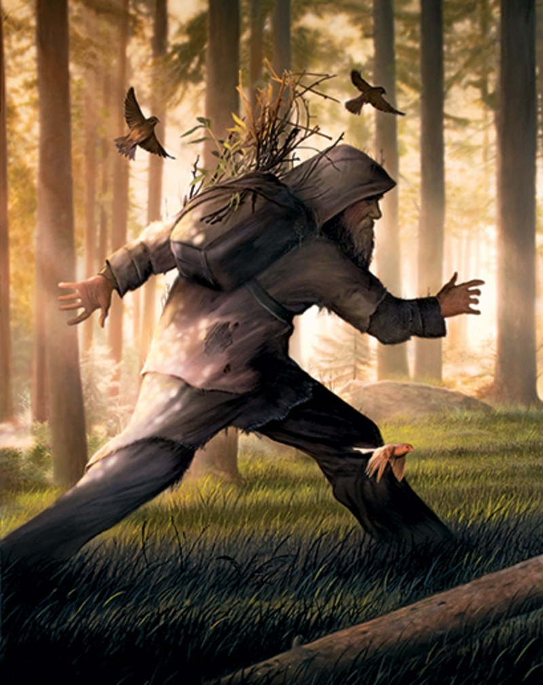

Illustration by Tim O’Brien

The thief complied, no resistance, and lay facedown, candy spilling out of his pockets. It was one thirty in the morning on April 4, 2013. Perkins-Vance soon arrived, and the burglar was placed, handcuffed, in a plastic chair. The officers asked his name. He refused to answer. His skin was strangely pale; his glasses, with chunky plastic frames, were extremely outdated. But he wore a nice Columbia jacket, new Lands’ End blue jeans, and sturdy boots. The officers searched him, and no identification was located.

Hughes left the suspect alone with Perkins-Vance. She removed his handcuffs and gave him a bottle of water. And he started to speak. A little. When Perkins-Vance asked why he didn’t want to answer any questions, he said he was ashamed. He spoke haltingly, uncertainly; the connection between his mind and his mouth seemed to have atrophied from disuse. But over the next couple of hours, he gradually opened up.

His name, he revealed, was Christopher Thomas Knight. Born on December 7, 1965. He said he had no address, no vehicle, did not file a tax return, and did not receive mail. He said he lived in the woods.

"For how long?" wondered Perkins-Vance.

Knight thought for a bit, then asked when the Chernobyl nuclear-plant disaster occurred. He had long ago lost the habit of marking time in months or years; this was just a news event he happened to remember. The nuclear meltdown took place in 1986, the same year, Knight said, he went to live in the woods. He was 20 years old at the time, not long out of high school. He was now 47, a middle-aged man.

Knight stated that over all those years he slept only in a tent. He never lit a fire, for fear that smoke would give his camp away. He moved strictly at night. He said he didn’t know if his parents were alive or dead. He’d not made one phone call or driven in a car or spent any money. He had never in his life sent an e-mail or even seen the Internet.

He confessed that he’d committed approximately forty robberies a year while in the woods—a total of more than a thousand break-ins. But never when anyone was home. He said he stole only food and kitchenware and propane tanks and reading material and a few other items. Knight admitted that everything he possessed in the world, he’d stolen, including the clothes he was wearing, right down to his underwear. The only exception was his eyeglasses.

Perkins-Vance called dispatch and learned that Knight had no criminal record. He said he grew up in a nearby community, and his senior picture was soon located in the 1984 Lawrence High School yearbook. He was wearing the same eyeglasses.

For close to three decades, Knight said, he had not seen a doctor or taken any medicine. He mentioned that he had never once been sick. You had to have contact with other humans, he claimed, in order to get sick.

When, said Perkins-Vance, was the last time he’d had contact with another person?

Sometime in the 1990s, answered Knight, he passed a hiker while walking in the woods.

"What did you say?" asked Perkins-Vance.

"I said, ’Hi,’ " Knight replied. Other than that single syllable, he insisted, he had not spoken with or touched another human being, until this night, for twenty-seven years.

Christopher Knight was arrested, charged with burglary and theft, and transported to the Kennebec County jail in Augusta, the state capital. For the first time in nearly 10,000 days, he slept indoors.

News of the capture stunned the citizens of North Pond. For decades, they’d felt haunted by…something. It was hard to say what. At first, in the late 1980s, there were strange occurrences. Flashlights were missing their batteries. Steaks disappeared from the fridge. New propane tanks on the grill had been replaced by old ones. "My grandkids thought I was losing my mind," said David Proulx, whose vacation cabin was broken into at least fifty times.

Then people began noticing other things. Wood shavings near window locks; scratches on doorframes. Was it a neighbor? A gang of teenagers? The robberies continued—boat batteries, frying pans, winter jackets. Fear took hold. "We always felt like he was watching us," one resident said. The police were called, repeatedly, but were unable to help.

Locks were changed, alarm systems installed. Nothing seemed to stop him. Or her. Or them. No one knew. A few desperate residents even left notes on their doors: "Please don’t break in. Tell me what you need and I’ll leave it out for you." There was never a reply.

Incidents mounted, and the phantom morphed into legend. Eventually he was given a name: the North Pond Hermit. At a homeowners’ meeting in 2002, the hundred people present were asked who had suffered break-ins. Seventy-five raised their hands. Campfire hermit stories were swapped. One kid recalled that when he was 10 years old, all his Halloween candy was stolen. That kid is now 34.

Still the robberies persisted. The crimes, after so long, felt almost supernatural. "The legend of the hermit lived on for years and years," said Pete Cogswell, whose jeans and belt were worn by the hermit when he was caught. "Did I believe it? No. Who really could?"

**[Uncatchable: The Story of Fugitive George Wright](https://www.gq.com/story/george-wright-fugitive-capture-story)**

Knight’s arrest, rather than eliminating disbelief, only enhanced it. The truth was stranger than the myth. One man *had* actually lived in the woods of Maine for twenty-seven years, in an unheated nylon tent. Winters in Maine are long and intensely cold: a wet, windy cold, the worst kind of cold. A week of winter camping is an impressive achievement. An entire season is practically unheard of.

Though hermits have been documented for thousands of years, Knight’s feat appears to exist in a category of its own. He engaged in zero communication with the outside world. He never snapped a photo. He did not keep a journal. His camp was undisclosed to everyone.

There may have been others like Knight, whose commitment to isolation was absolute—he planned to live his entire life in secret—but if so, they were never found. Capturing Knight was the human equivalent of netting a giant squid. He was an uncontacted tribe of one.

Reporters across Maine, and soon enough across the nation and the world, attempted to contact him. What did he wish to tell us? What secrets had he uncovered? How had he survived? He stayed resolutely silent. Even after his arrest, the North Pond Hermit remained a complete mystery.

I decided to write him a letter. I wrote it by hand, pen on paper, and sent it from my home in Montana to the Kennebec County jail. I mentioned I was a journalist seeking explanations for his baffling life. A week later, a white envelope arrived in my mailbox. The return address, printed in blue ink in wobbly-looking block letters, read "Chris Knight." It was a brief note—three paragraphs; 272 words. Still, it contained some of the first statements Knight had shared with anyone in the world.

"I replied to your letter," he explained, "because writing letters relieves somewhat the stress and boredom of my present situation." Also, he didn’t feel comfortable speaking. "My vocal, verbal skills have become rather rusty and slow."

I’d mentioned in my letter that I was an avid reader. From what I could tell, Knight was, too. Many victims of Knight’s thefts reported that their books were often stolen—from Tom Clancy potboilers to dense military histories to James Joyce’s *Ulysses.*

Hemingway, I wrote, was one of my favorites. It seemed that Knight was shy about everything except literary criticism; he answered that he felt "rather lukewarm" about Hemingway. Instead, he noted, he’d rather read Rudyard Kipling, preferably his "lesser known works." As if catching himself getting a little friendly, he added that since he didn’t know me, he really didn’t want to say more.

Then he seemed concerned that he was now being too unfriendly. "I wince at the rudeness of this reply but think it better to be clear and honest rather than polite. Tempted to say ’nothing personal,’ but handwritten letters are always personal." He ended with: "It was kind of you to write. Thank you." He did not sign his name.

I wrote him back and sent him a couple of Kiplings *(The Man Who Would Be King* and *Captains Courageous)*. His response, two and a half pages, felt as raw and honest as a diary entry. He was suffering in jail; the noise and the filth tore at his senses. "You asked how I sleep. Little and uneasy. I am nearly always tired and nervous." In his next letter, he added, in his staccato, almost song-lyric style, that he deserved to be imprisoned. "I stole. I was a thief. I repeatedly stole over many years. I knew it was wrong. Knew it was wrong, felt guilty about it every time, yet continued to do it."

We exchanged letters throughout the summer of 2013. Rather than becoming gradually more accustomed to jail, to being around other people, Knight was deteriorating. In the woods, he said, he’d always carefully maintained his facial hair, but now he stopped shaving. "Use my beard," he wrote, "as a jail calendar."

He tried several times to converse with other inmates. He could force out a few hesitant words, but every topic—music, movies, television—was lost on him, as was most slang. "You speak like a book," one inmate teased. Whereupon he ceased talking.

"I am retreating into silence as a defensive move," he wrote. Soon he was down to uttering just five words, and only to guards: yes; no; please; thank you. "I am surprised by the amount of respect this garners me. That silence intimidates puzzles me. Silence is to me normal, comfortable."

He wrote little about his time in the woods, but what he did reveal was harrowing. Some years, he made it clear, he barely survived the winter. In one letter, he told me that to get through difficult times, he tried meditating. "I didn’t meditate every day, month, season in the woods. Just when death was near. Death in the form of too little food or too much cold for too long." Meditation worked, he concluded. "I am alive and sane, at least I think I’m sane." As always there was no formal closing. His letters simply ended, sometimes mid-thought.

He returned to the theme of sanity in a following letter. "When I came out of the woods they applied the label hermit to me. Strange idea to me. I had never thought of myself as a hermit. Then I got worried. For I knew with the label hermit comes the idea of crazy. See the ugly little joke."

Even worse, he feared his time in jail would only prove correct those who doubted his sanity. "I suspect," he wrote, "more damage has been done to my sanity in jail, in months; than years, decades, in the woods."

His legal proceedings were mired in delays, as the district attorney and his lawyer tried to figure out how justice could be served in a case entirely without precedent.

After four months in jail, Knight had no clue what punishment awaited. A sentence of a dozen or more years was possible. "Stress levels sky high," he wrote. "Give me a number. How long? Months? Years? How long in prison for me. Tell me the worst. How long?"

In the end, he decided he could not even write. "For a while writing relieved stress for me. No longer." He sent one last, heartbreaking letter in which he seemed at the verge of breakdown. "Still tired. More tired. Tireder, tiredest, tired ad nauseam, tired infinitum."

And that was it. He never wrote me again. Though he did finally sign his name. Despite the exhaustion and the tension, the last words he penned were wry and self-mocking: "Your friendly neighborhood Hermit, Christopher Knight."

Three weeks after his final letter, I flew to Maine. The Kennebec County jail, a three-story slab of pale gray cinder blocks, permits visitors most evenings at six forty-five. I arrived early. "Who you here to see?" asked a corrections officer.

"Christopher Knight."

"Relationship?"

"Friend," I answered unconfidently. He didn’t know I was here, and I had my doubts he’d see me.

I sat on a bench as other visitors checked in. Beyond the walls of the waiting room, I could hear piercing buzzers and slamming doors. Eventually an officer appeared and called out, "Knight."

He unlocked a maroon door and I stepped inside a visitors’ booth. Three short stools were bolted to the floor in front of a narrow desk. Over the desk, dividing the booth into sealed-off halves, was a thick pane of shatterproof plastic. Sitting on a stool on the other side of the pane was Christopher Knight.

Rarely in my life have I witnessed someone less pleased to see me. His lips, thin, were pulled into a downturned scowl. His eyes did not rise to meet mine. I sat across from him, and there was no acknowledgment of my presence, not the merest nod. He gazed someplace beyond my left shoulder. He was wearing a dull green overlaundered jail uniform several sizes too big.

A black phone receiver was hanging on the wall. I picked it up. He picked his up—the first movement I saw him make.

I spoke first. "Nice to meet you, Chris."

He didn’t respond. He just sat there, stone-faced. His balding head shone like a snowfield beneath the fluorescent lights; his beard was a mess of reddish brown curls. He had on silver-framed glasses, different from the ones he’d worn forever in the woods. He was very skinny. He’d lost a great deal of weight since his arrest.

I tend to babble when I’m nervous, but I made a conscious effort to restrain myself. I recalled what Knight wrote in his letter about being comfortable with silence. I looked at him not looking at me. Maybe a minute passed.

That was all I could endure. "The constant banging and buzzing in here," I said, "must be so jarring compared with the sounds of nature." He shifted his eyes to me—a small victory—then glanced away. His eyes are light brown. He scarcely has any eyebrows. I let my comment hang in the air.

Then he spoke. Or at least his mouth moved. His first words to me were inaudible. I saw why: He was holding the phone’s mouthpiece too low, below his chin. It had been decades since he’d used a phone; he was out of practice. I indicated with my hand that he needed to move it up. He did. And he repeated his grand pronouncement.

"It’s jail," he said. There was nothing more. Silence again.

I shouldn’t have come. He didn’t want me here; I didn’t feel comfortable being here. But the jail had granted me a one-hour visit, and I resolved to stay. I settled atop my stool. I felt hyperaware of all my gestures, my expressions, my breathing. Chris’s right leg, I saw through the scuffed window, was bouncing rapidly. He scratched at his skin.

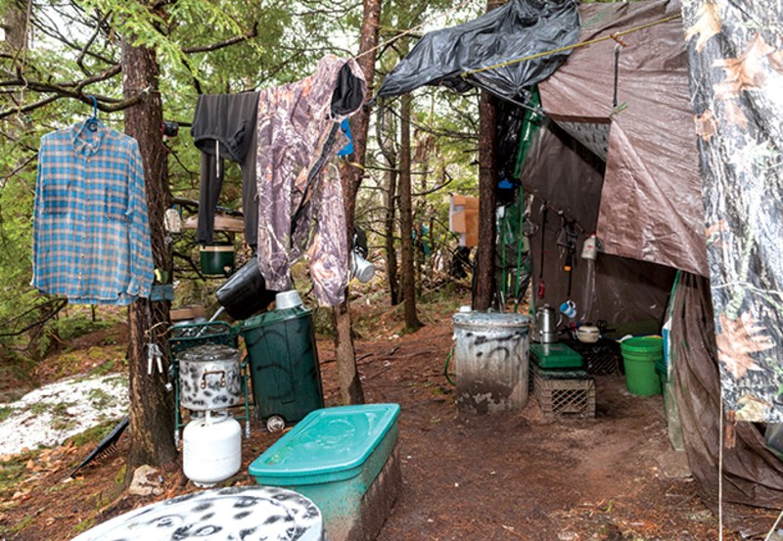

My patience was rewarded. First his leg settled down. He quit scratching. And then, rather shockingly, he started talking.

"Some people want me to be this warm and fuzzy person. All filled with friendly hermit wisdom. Just spouting off fortune-cookie lines from my hermit home."

His voice was clear; he’d retained the stretched vowels of a Down East Maine accent. And his words, when he deigned to release them, could evidently be imaginative and entertaining. And caustic.

"Your hermit home—like under a bridge?" I said, trying to play along.

He presented me with an achingly long blink.

"You’re thinking of a troll."

I laughed. His face moved in the direction of a smile. We had made a connection—or at least the awkwardness of our introduction had softened. We began to converse somewhat normally. He called me Mike and I called him Chris.

He explained about the lack of eye contact. "I’m not used to seeing people’s faces," he said. "There’s too much information there. Aren’t you aware of it? Too much, too fast."

I followed his cue and looked over his shoulder while he stared over mine. We maintained this arrangement for most of the visit. Chris had recently been given a mental-health evaluation by Maine’s forensic service. The report mentioned a possible diagnosis of Asperger’s disorder, a form of autism often marked by exceptional intelligence but extreme sensitivity to motions, sounds, and light.

Chris had just learned of Asperger’s while in jail, and he seemed unfazed by the diagnosis. "I don’t think I’ll be a spokesman for the Asperger’s telethon. Do they still do telethons? I hate Jerry Lewis." He said he was taking no medications. "But I don’t like people touching me," he added. "You’re not a hugger, are you?"

I admitted that I do at times participate in embraces.

"I’m glad this is between us," he said, indicating the glass. "If there was a set of blinds here, I’d close them."

There was a part of me that was perversely charmed by Chris. He could seem prickly—he *is* prickly—but this was merely a protective cover. He told me that since his capture, he’d often found himself emotionally overwhelmed at unexpected moments. "Like TV commercials," he said, "have made me teary. It’s not a good thing in jail to have people see you crying."

Everything he said seemed candid and blunt, unfiltered by the safety net of social niceties. "I’m not sorry about being rude if it gets to the point quicker," he told me.

That’s fine, I said, though I expected to ask questions that might kindle his rudeness. But I started with a gentle one: What was your life like before you went into the forest?

Before he slept in the woods for a quarter century straight, Chris never once spent a night in a tent. He was raised in the community of Albion, a forty-five-minute drive east of his camp; he has four older brothers and one younger sister. His father, who died in 2001, worked in a creamery. His mother, now in her eighties, still lives in the same house where Chris grew up, a modest two-story colonial on a wooded fifty-acre plot.

The family is extremely private and did not speak with me. Their next-door neighbor told me that in fourteen years, he hasn’t exchanged more than a word with Chris’s mom. Sometimes he sees her getting the paper. "Culturally my family is old Yankee," Chris said. "We’re not emotionally bleeding all over each other. We’re not touchy-feely. Stoicism is expected."

Chris insisted that he had a fine childhood. "No complaints," he said. "I had good parents." He shared vivid stories of moose hunting with his father. "A couple of hunting trips I slept in the back of the pickup, but never alone and never in a tent." After he’d disappeared, his family apparently didn’t report him missing to the police, though they may have hired a private detective. No one uncovered a clue. Two of Chris’s brothers, Joel and Tim, visited him in jail. "I didn’t recognize them," Chris admitted.

"My brothers supposed I was dead," said Chris, "but never expressed this to my mom. They always wanted to give her hope. Maybe he’s in Texas, they’d say. Or he’s in the Rocky Mountains." Chris did not allow his mother to visit. "Look at me, I’m in my prison clothes. That’s not how I was raised. I couldn’t face her."

He said he had excellent grades in high school, though no friends, and graduated early. Like two of his brothers, he enrolled in a nine-month electronics course at Sylvania Technical School in Waltham, Massachusetts. Then, still in Waltham, he took a job installing home and vehicle alarm systems; valuable knowledge to have once he started stealing.

He bought a new car, a white 1985 Subaru Brat. His brother Joel co-signed the loan. "I screwed him on that," Chris said. "I still owe him." He worked less than a year before he quit. He drove the Brat to Maine, went through his hometown without stopping—"one last look around"—and kept driving north. Soon he reached the edge of Moosehead Lake, where Maine begins to get truly remote.

"I drove until I was nearly out of gas. I took a small road. Then a small road off that small road. Then a trail off that." He parked the car. He placed the keys in the center console. "I had a backpack and minimal stuff. I had no plans. I had no map. I didn’t know where I was going. I just walked away."

It was late summer of 1986. He’d camp in one spot for a week or so, then hike south, following the natural geology of Maine, with its long, glacier-carved valleys. "I lost track of where I was," he said. "I didn’t care." For a while, he tried foraging for food. He ate roadkill partridges. Then he began taking corn and potatoes from people’s gardens.

"But I wanted more than vegetables," he said. "It took a while to overcome my scruples. I was always scared when stealing. Always." He insists he never encountered anyone during a robbery; he made sure there was no car in the driveway, no sign of anyone inside. "It was usually 1 or 2 A.M. I’d go in, hit the cabinets, the refrigerator. In and out. My heart rate was soaring. It was not a comfortable act. I took no pleasure in it, none at all, and I wanted it over as quickly as possible." A single mistake, he understood, and the outside world would snatch him back.

He roamed about for two years before he discovered the campsite he would call home. He knew at once it was ideal. "Then," he said, "I settled in."

The majority of North Pond residents I spoke with found it hard to believe Knight’s story. Many insisted that he either had help or spent the winters in unoccupied cabins. As the time allotted for our visit wound down, I challenged Chris myself: You must, I said, have had assistance at some time. Or slept in a cabin. Or used a bathroom.

Chris’s demeanor changed. It was the only time in our meeting that he held eye contact. "Never once did I sleep inside," he said. He never used a shower. Or a toilet.

He did admit to thawing meat in a microwave a few times during break-ins. But he endured every season entirely on his own. "I’m a thief. I induced fear. People have a right to be angry. But I have not lied."

I trusted him. I sensed, in fact, that Chris was practically incapable of lying. I wasn’t alone in this thought. Diane Perkins-Vance, the state trooper present at his arrest, told me that much of her job consisted of sorting through lies people fed her. With Chris, however, she had no doubts. "Unequivocally," she said, "I believe him."

Before he hung up the phone, Chris added that if I could see where he lived and how he survived, I’d know for sure.

It was my plan to find his camp. Afterward, I said, I’d like to return to the jail. Could we meet again?

His answer was unexpected. He said, "Yes."

The Belgrade Lakes area, where Knight lived, is cow-and-horse rural, nothing like the vast North Woods of Maine, wild and unpeopled. Knight’s camp was located on private property, just a few hundred feet from the nearest cabin, in an area crisscrossed by dirt roads.

When I saw Knight’s woods myself, I understood how he could remain there unnoticed. The tangle of hemlock and maple and elm is so dense the forest holds its own humidity; one step in and my glasses fogged.

But what made navigation truly treacherous were the boulders—vehicle-sized glacier-borne gifts from the last ice age—scattered wildly and everywhere. I thrashed about for an hour, wrenched a knee between two moss-slick rocks, then gave up and retreated to a road.

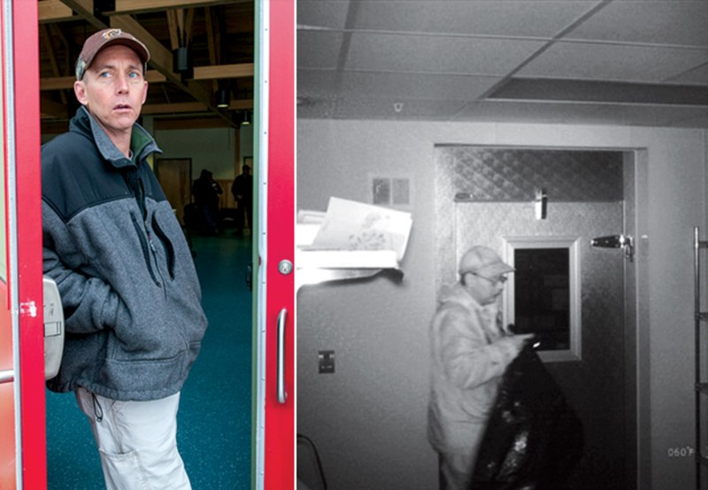

Before Chris was jailed, he’d led Hughes and Perkins-Vance to his camp; I knew roughly where it was located, but my second attempt was also a failure. There was no hint of a trail. Mosquitoes swarmed. Finally, reduced to slogging in a gridlike pattern, I squeezed around a boulder and there it was.

My goodness. Chris had carved from the chaos a bedroom-sized clearing completely invisible from a few steps away, situated on a slight rise that allowed enough breeze to keep the mosquitoes away, but not so much as to cause severe windchill in winter. It was surrounded by a natural Stonehenge of boulders; overhead, tree branches linked to form a trellis-like canopy that masked his site from the air. This is why Chris’s skin was so pale—he’d lived in perpetual shade. I ended up staying there three nights, watching the rabbits by day, at night picking out a few stars behind the scrim of branches. It was as gorgeous and peaceful a place as I have ever spent time.

The police had dismantled much of his camp, but during my next visit with Chris, and several after that, he described his living space in meticulous detail. In total, Chris and I met at the jail for nine hours.

He slept in a simple camping tent, which he kept covered by several layers of brown tarps. Camouflage, he felt, was essential; he didn’t want to risk anything shiny catching someone’s eye, so he spray-painted, in foresty colors, his garbage bins and his coolers and his cooking pot. He even painted his clothespins green.

The breadth of his thievery was impressive. He’d fled the modern world only to live off the fat of it. Inside his tent was a metal bedframe he’d removed from the Pine Tree Camp; he had hauled it across the pond in a canoe. He didn’t steal the canoe. He just borrowed one, as he often did, from a lakeside cabin—"there’s a wide selection"—then returned it, sprinkling pine needles inside to make it seem unused. He also stole a box spring and mattress and sleeping bags.

He stole toilet paper and hand sanitizer for his bathroom spot. He took laundry detergent and shampoo for his wash area. There was no fire pit, as he’d insisted. He cooked on a Coleman two-burner stove that he connected to propane tanks. He stole a tremendous number of tanks, pillaging gas grills along the thirty-mile circumference of the pond. He never returned them. He buried the tanks—possibly hundreds of them—in his dump at the camp’s edge.

He stole deodorant, disposable razors, flashlights, snow boots, spices, mousetraps, spray paint, and electrical tape. He took pillows off beds. He kept three different types of thermometers in camp: digital, mercury, spring-loaded. Knowing the exact temperature was mandatory. He stole watches—he had to be sure, while on a raid, that he could return to camp before daybreak.

Deeper into the forest, in his "upper cache," as he called it, he’d stashed plastic totes filled with enough supplies—a tent and a sleeping bag, some warm clothes—so that if he heard someone approach his camp, he could instantly abandon it and start anew. He was committed.

His diet was terrible. "Cooking is too kind a word for what I did," Chris told me. He’d not been sick in the woods, and his worst accident was a tumble on some ice, but his teeth were rotten, and no wonder. I dug through his twenty-five years of trash, buried between boulders, and kept inventory: a five-pound tub that once held Marshmallow Fluff, an empty box of Devil Dogs, peanut butter, Cheetos, honey, graham crackers, Cool Whip, tuna fish, coffee, Tater Tots, pudding, soda, El Monterey spicy jalapeño chimichangas, and on and on and on.

He stole radios and earphones and hid an antenna up in trees. For a while, he listened to a lot of conservative talk radio. Later he got hooked on classical music—Tchaikovsky and Brahms, yes; Bach, no. "Bach is too pristine," he said. He went through a spell of listening to television shows on the radio; "theater of the mind," he called it. *Everybody Loves Raymond* was a favorite. But his undying passion was classic rock: the Who, AC/DC, Judas Priest, and above all, Lynyrd Skynyrd. We covered hundreds of topics while chatting in jail, and nothing received higher praise than Lynyrd Skynyrd. "They will be playing Lynyrd Skynyrd songs in a thousand years," he proclaimed.

He also stole the occasional handheld video game—Pokémon, Tetris, Dig Dug—but the majority of his free time was spent reading or observing the forest. "Don’t mistake me for some bird-watching PBS type," he warned, but then proceeded to poetically describe the crunch of dry leaves underfoot ("walking on corn flakes") and the rumble of an ice crack propagating across the pond ("like a bowling ball rolling down an alley").

He stole hundreds of books over the years; his preference was military history—he named William Shirer’s *The Rise and Fall of the Third Reich* as his favorite book—but he took whatever was available. Magazines were more common. When he finished them, he’d create bricks of magazines, bound with electrical tape, and bury them in the ground to level out his camp. Beneath his tent area were dozens of these bricks.

I unearthed a stack of _National Geographic_s with the dates still legible: 1991 and 1992. I also saw *People, Cosmopolitan, Glamour,* and *Vanity Fair.* There was even a collection of _Playboy_s. One book Chris never stole was the Bible. "I can’t claim a belief system," he said. He celebrated no holidays. He meditated now and then but did not pray.

With one exception. When the worst of a Maine winter struck, all rules were suspended. "Once you get below negative twenty, you purposely don’t think," he told me. His eyes went wide and fearful from the memory. "That’s when you do have religion. You do pray. You pray for warmth."

Chris lived by the rhythms of the seasons, but his thoughts were dominated by surviving winter. Preparations began at the end of each summer as the lakeside cabins were shutting down for the year. "It was my busiest time," he said. "Harvest time. A very ancient instinct. Though not usually associated with crime."

His first goal was to get fat. This was a life-or-death necessity. "I gorged myself on sugar and alcohol," he said. "It’s the quickest way to gain weight, and I liked the inebriation." The bottles he stole were signs of a man who’d never once, as he admitted, ordered a drink at a bar: Allen’s Coffee Flavored Brandy, Seagram’s Escapes Strawberry Daiquiri, something called Whipped Chocolate Valley Vines (from the label: "fine chocolate, whipped cream red wine").

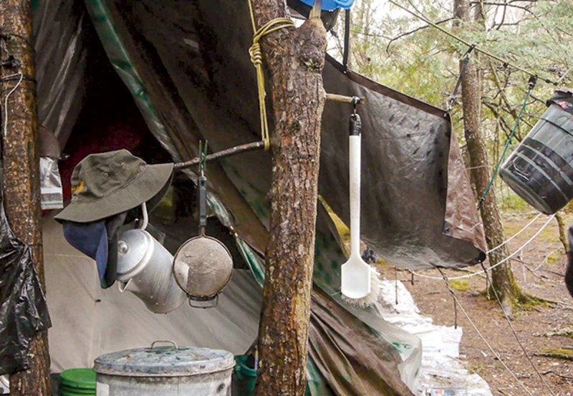

As the evenings began to chill, he grew his beard to the ideal length—about an inch, long enough to insulate his face, short enough to prevent ice buildup. He intensified his thieving raids, stocking up on food and propane. The first snow usually came in November. Chris was always fearful about leaving a single boot print anywhere, which is impossible to avoid in a blanket of snow. And so for the next six months, until the spring thaw in April, Chris rarely strayed from his clearing in the woods.

I asked him if he just slept all the time, a human hibernation. "Completely wrong," he replied. "It’s dangerous to sleep too long in winter." When seriously frigid weather descended, he conditioned himself to fall asleep at 7:30 P.M. and get up at 2 A.M. "That way, at the depth of cold, I was awake." If he remained in bed any longer, condensation from his body could freeze his sleeping bag. "If you try and sleep through that kind of cold, you might never wake up."

The first thing he’d do at 2 A.M. was light his stove and start melting snow. To get his blood circulating, he’d pace the perimeter of his camp. His feet never seemed to fully thaw, but as long as he had a fresh pair of socks, this wasn’t a problem. "It’s more important to be dry than warm," Chris said. By dawn, he’d have his day’s water supply. "Then, if I had had food, I’d have a meal."

And if he didn’t have food? There were, he said, some very hard winters—desperate winters—in which he ran out of propane and finished his food. The suffering was acute. Chris called it "physical, emotional, and psychological pain." He hinted to me there were times he contemplated suicide.

Why not just leave the woods? Chris said he thought about it. He even kept a whistle in his camp. "If I blew on it in sequences of three, help might come." But he never used it. Rather, he made a firm decision that unless forcibly removed, he was going to spend the rest of his life behind the trees.

When he heard the song of the chickadees, he told me, he could finally relax. "That alerted me that winter is starting to lessen its grip. That the end is near. That spring is coming and I’m still alive."

The cold never got easier. All his winter-camping expertise felt offset by advancing age. "You should have seen me in my twenties," he boasted. "I was lord of the woods. I ruled the land I walked upon. I was tough and clever." But over time, like an aging athlete, his body began to break down. The biggest issue was his eyesight. "For the last ten years, anything beyond an arm’s length was a blur. I used my ears more than my eyes." If he saw a pair of glasses during a break-in, he always tried them on, but was unable to find a better prescription. His agility faded; bruises took longer to heal. His teeth constantly hurt.

The victims of his thefts, after years of waiting for a police breakthrough, eventually took matters into their own hands. Neal Patterson, whose family has owned a place on the pond for fifty years, began hiding all night in his dark house with a .357 Magnum in his hand. "I wanted to be the guy that caught the hermit," he said. He stayed up fourteen nights one summer before he quit.

Debbie Baker, whose young boys were terrified of the hermit—to quell their fears, the family renamed him "the hungry man"—installed a surveillance camera in their cabin. And in 2002, they captured a photo of Knight. The police widely distributed the photo and figured an arrest was imminent.

It took eleven more years. After a robbery in March of 2013 at the Pine Tree Camp, Sergeant Terry Hughes, who often volunteered there, contacted the border patrol for advice. "It had gone on long enough," said Hughes. He installed a motion detector that sounded an alarm at his house and practiced dashing from his bed to the camp until he had it down under four minutes. Then Hughes waited for the hermit to return.

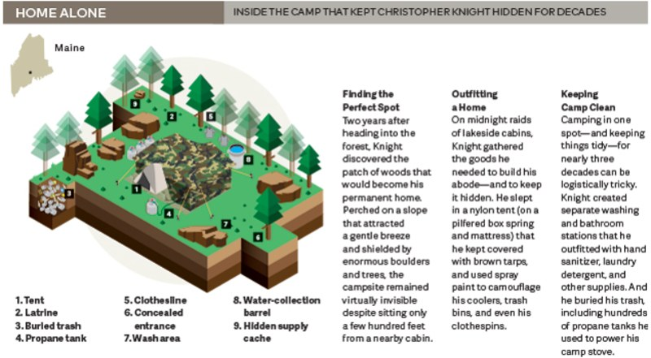

Following his arrest, the court of public opinion was deeply divided. The man who wanted to live his life as invisibly as possible had become one of the most famous people in Maine. You could not walk into a bar in the Augusta area without stumbling into a debate about what should be done with Christopher Knight.

Some said that he must immediately be released from jail. Stealing cheese and bacon are not serious crimes. The man was apparently never violent. He didn’t carry a weapon. He’s an introvert, not a criminal. He clearly has no desire to be a part of our world. Let’s open a Kickstarter, get him enough cash for a few years’ worth of groceries, and allow him to go back to the woods. Some people were willing to let him live on their land, rent-free.

Others countered that it wasn’t the physical items he robbed that made his crimes so disturbing—he stole hundreds of people’s peace of mind. Their sense of security. How were they supposed to know Knight wasn’t armed and dangerous? Even a single break-in can be punishable by a ten-year sentence. If Knight really wanted to live in the woods, he should’ve done so on public lands, hunting and fishing for food. He’s nothing but a lazy man and a thief times a thousand. Lock him up in the state penitentiary.

On October 28, 2013, Chris appeared in Kennebec County Superior Court and pleaded guilty to thirteen counts of burglary and theft. He was sentenced to seven months in jail—he’d already served all but a week of this, waiting for his case to be resolved. The sentence was far more lenient than it could have been, though even the prosecutor said a long prison term seemed cruel in this case. Chris was ordered to meet with a judge every Monday, and avoid alcohol, and either find a job or go to school. If he violated these terms, he could be sent to prison for seven years.

Before his release, I met with Chris again. He said he’d be returning home, to live with his mother. His beard was unruly—"my crazy hermit beard," he called it. He was alarmingly skinny; he itched all over. We still didn’t make much eye contact.

"I don’t know your world," he said. "Only my world, and memories of the world before I went into the woods. What life is today? What is proper? I have to figure out how to live." He wished he could return to his camp—"I miss the woods"—but he knew by the rules of his release that this was impossible. "Sitting here in jail, I don’t like what I see in the society I’m about to enter. I don’t think I’m going to fit in. It’s too loud. Too colorful. The lack of aesthetics. The crudeness. The inanities. The trivia."

I told him I agreed with much of his assessment. But, I wondered, what about your world? What insights did you glean from your time alone? I had been trying to ask him these questions every visit, but now I pushed the point harder.

Anyone who reveals what he’s learned, Chris told me, is not by his definition a true hermit. Chris had come around on the idea of himself as a hermit, and eventually embraced it. When I mentioned Thoreau, who spent two years at Walden, Chris dismissed him with a single word: "dilettante."

True hermits, according to Chris, do not write books, do not have friends, and do not answer questions. I asked why he didn’t at least keep a journal in the woods. Chris scoffed. "I expected to die out there. Who would read my journal? You? I’d rather take it to my grave." The only reason he was talking to me now, he said, is because he was locked in jail and needed practice interacting with others.

"But you must have thought about things," I said. "About your life, about the human condition."

Chris became surprisingly introspective. "I did examine myself," he said. "Solitude did increase my perception. But here’s the tricky thing—when I applied my increased perception to myself, I lost my identity. With no audience, no one to perform for, I was just there. There was no need to define myself; I became irrelevant. The moon was the minute hand, the seasons the hour hand. I didn’t even have a name. I never felt lonely. To put it romantically: I was completely free."

That was nice. But still, I pressed on, there must have been some grand insight revealed to him in the wild.

He returned to silence. Whether he was thinking or fuming or both, I couldn’t tell. Though he did arrive at an answer. I felt like some great mystic was about to reveal the Meaning of Life.

"Get enough sleep."

He set his jaw in a way that conveyed he wouldn’t be saying more. This is what he’d learned. I accepted it as truth.

"What I miss most," he eventually continued, "is somewhere between quiet and solitude. What I miss most is stillness." He said he’d watched for years as a shelf mushroom grew on the trunk of a Douglas fir in his camp. I’d noticed the mushroom when I visited—it was enormous—and he asked me with evident concern if anyone had knocked it down. I assured him it was still there. In the height of summer, he said, he’d sometimes sneak down to the lake at night. "I’d stretch out in the water, float on my back, and look at the stars."

At the very end of each of our visits, I’d always asked him the same question. An essential question: Why did he disappear?

He never had a satisfying answer. "I don’t have a reason." "I can’t explain why." "Give me more time to think about it." "It’s a mystery to me, too." Then he became annoyed: "Why? That question bores me."

But during our final visit, he was more reflective. Isn’t everybody, he said, seeking the same thing in life? Aren’t we all looking for contentment? He was never happy in his youth—not in high school, not with a job, not being around other people. Then he discovered his camp in the woods. "I found a place where I was content," he said. His own perfect spot. The only place in the world he felt at peace.

That was all he had to tell me. He’d grown weary of my visits. Please, he begged, leave me alone; we are not friends. I don’t want to be your friend, he said, I don’t want to be anyone’s friend. "I’m not going to miss you at all," he added.

I liked Chris, a great deal. I liked the way his mind worked; I liked the lyricism of his language. But he was a true hermit. He could no longer disappear into the wild, so he wished to melt away into the world.

"Good-bye, Chris," I said. A guard had appeared to escort him away, but there was time for Chris to express a last thought. He did not. He hung up the phone. No wave; no nod. He stood, turned his back on me, and walked out of the visitors’ booth and down a corridor of the jail.