Shakespeare – Influential People in His Life

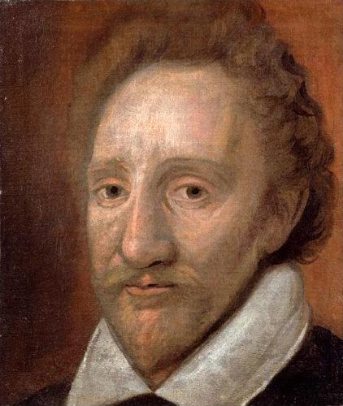
Richard Burbage was Shakespeare’s lead tragedian and the first actor to play Richard III, Hamlet, Othello, and King Lear. Richard and Shakespeare may have first met when they were both children. Richard was in Stratford with the theatre company of his father James Burbage, who was also an actor, manager, and pioneering theatre maker.

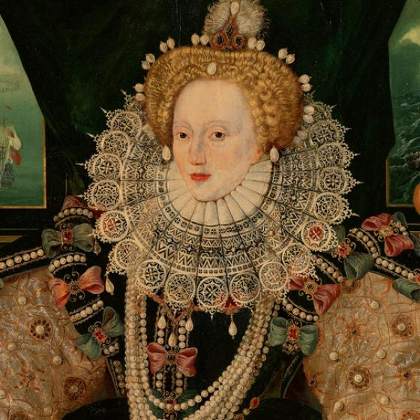
Elizabeth I reigned for 44 years, an incredibly long time when the average life-span was only 35. She was the last of the dynasty known as the Tudors (descended from the Welshman, Owen Tudor, who married the widow of Henry V). She was monarch for most of Shakespeare’s life, and his company’s patron.

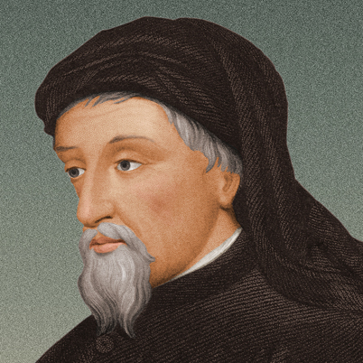
Geoffrey Chaucer was the master of stories in the 14th century, whose fables (The Canterbury Tales) still rang clear in Elizabethan heads. He was the equivalent of our Charles Dickens, Brothers Grimm, or Hans Christian Andersen, and was often called ‘Father’ Chaucer. Shakespeare knew his stories well, and sometimes refers to them in his plays.

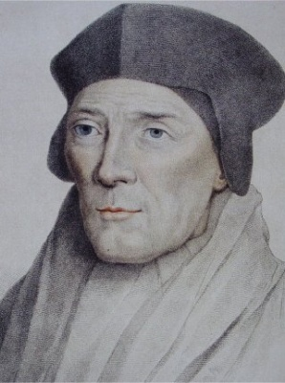
Raphael Holinshed’s book, The Chronicles of England, Scotland and Ireland, was the chief source for the plot of Macbeth and many of Shakespeare’s history plays, including Henry V. First published in 1577, it was the first comprehensive work on British history and a common plot-source for Elizabethan writers.

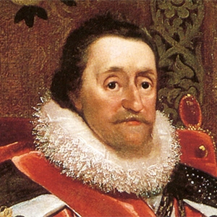
King James I of Scotland succeeded Queen Elizabeth I in 1603 as James I of England, and wrote a book about witches called Daemonologie. He also survived as assassination attempt by Guy Fawkes on November 5th. The plot of Macbeth – written the following year and featuring the killing of a Scottish king, and witches – may well have had some personal significance to him.
King’Men – When Queen Elizabeth died, the future of Shakespeare’s theatre company looked uncertain. Fortunately, King James I took over patronage and the company became known as The King’s Men. The actors remained the King’s favourites until Shakespeare stopped writing in 1614.

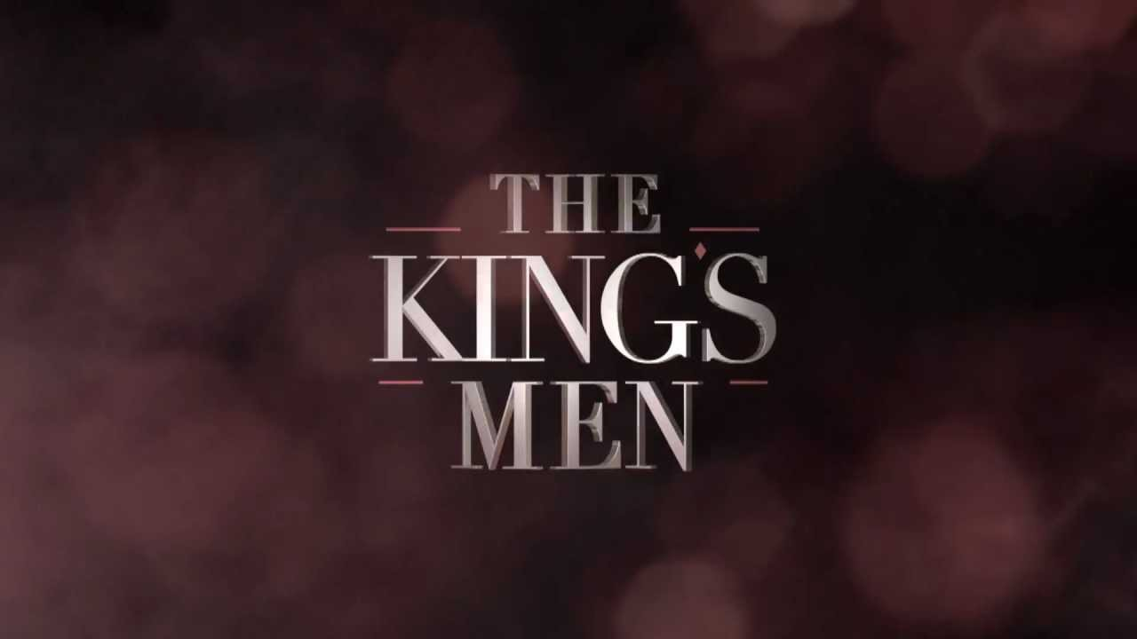

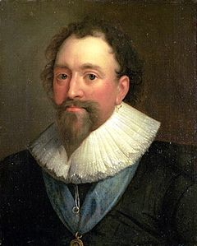
Lord Chamberlain’s Men – Every theatre company needed a patron. Shakespeare’s actors quickly gained Queen Elizabeth I as theirs, under the careful watch of her most senior royal official, the Lord Chamberlain, which gave them their name. Under James I, they became The King’s Men. In Shakespeare’s lifetime, 9 men served as Lord Chamberlain. Pictured here is William Herbert, the Earl of Pembroke, who was Lord Chamberlain in 1616 – the year that Shakespeare died.

Christopher Marlowe was the great playwright before Shakespeare hit the big time. The lead character of his play, The Jew of Malta, was possibly a source of inspiration for Shylock in Shakespeare’s Merchant of Venice. Some believe that Marlowe’s death in 1593 (he was stabbed in the eye while arguing over a bill in a tavern) was faked and he secretly went to live in Italy.

