Writing Assignment #3

You are having your cards read. You receive “The Empress”. The card reader expresses amazement and tells you the following... Write out the dialogue.

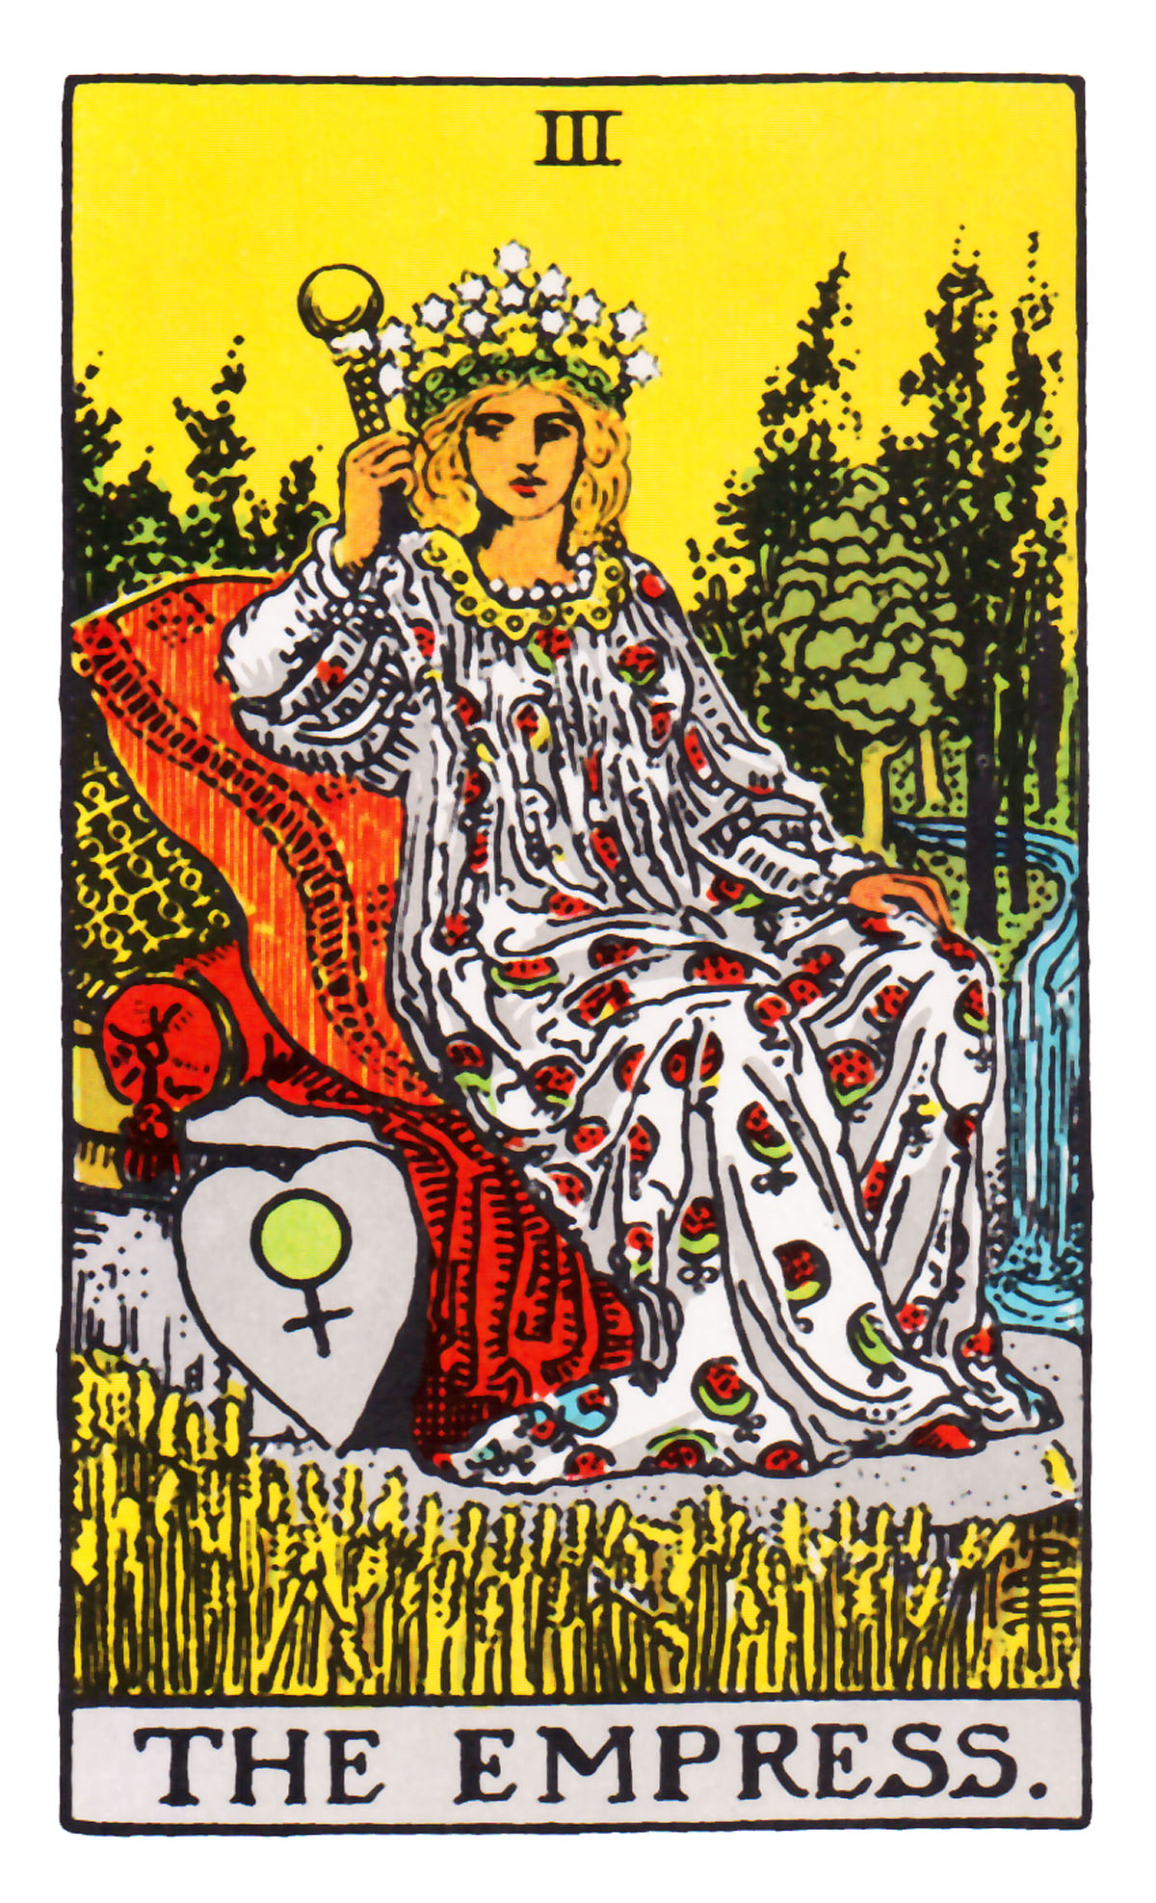

Length: 1 page (max.)

By the way…
In the world of Tarot cards, The Empress represents a creator, be it creation of life, of romance, of art, or of business.

